**Pragmatic Information Theory**

A business philosophy of information

Dr. A Kukler MFE

Amsterdam, March 23, 2018

**Abstract**

The Pragmatic Information Theory is a newly designed concept intended to help managers to improve the value of their company’s information, the most important asset. It is pragmatic because it deals with actual issues in day-to-day management life and focused on use of information in applications as criterion for success. It is a new view on information based on the virtual character of it, as opposed to the real (physical world) character of things like money or matter. Information is referential, reflexive and is multiplied when divided, hence needs a different approach.

As the focus is on use, the concept of Chain of Information is presented which can be used as a tool to actually manage the value of specific information flows. It helps to identify the weak spots in the chain. Improvement of the weakest spots increases the value of the chain.

Next, a first application of the chain-concept in portfolio management within a bank is elaborated as illustration of its practical use. Finally, adjacent theories that have been inspiring, such as cybernetics, risk society and asymmetric information, and their relation to Pragmatic Information Theory are described.

**Contents**

Introduction in the age of digital information 2

Introduction into Pragmatic Information Theory 3

Information is different 5

Referential character invokes the Chain concept 6

Chain of Information 8

Application of the Chain concept 10

Literature and adjacent theories 12

Literature list 17

## Introduction in the age of digital information

We live in an era where money is spent most on information, more than on any other asset. Intangible assets are the largest asset class in the US since the 1990s (see picture below). It shows the ratio of intangible to tangible assets in percentages. In 1990 intangible assets were 10% higher than tangible assets.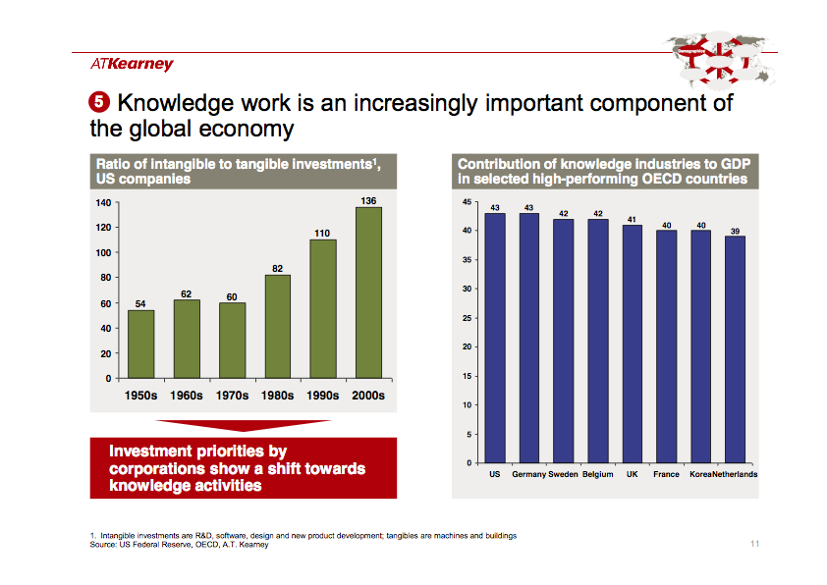

Information is key in today’s businesses, more than capital. Superiority in information processing is determinant for success in the market place. Information is replacing capital as the key resource. This is as one of many examples caused by risk adjustment in valuations, which is common in financial theory. Risk (as uncertainty) is the inverse of knowledge. If you have perfect knowledge, risk is zero, hence the valuation adjustment is zero. Compared to a situation with imperfect information, hence uncertainty, hence a (downward) valuation adjustment, profit is higher with perfect information. The concept of risk offers a strong transformation mechanism to convert information into money. Since the end of last millennium, according to Beck[[1]](#footnote-0), our society is becoming a risk society, information moves to the centre of our attention.

The newness in this era is not information sec, but its digital form, being carried by ICT (Information and Communication Technology). This digital form makes it different from information on material or physical carrier. This can be observed in the typical actions when processing digital information:

1. Copy - Paste: with a simple press button, a complete document is copied in a split second. The result of the hard work to create the document is duplicated with a simple press button. In physical form, copying is *monk’s work*, takes a lot of time and effort.
2. Delete: erase something without leaving a trace, by simple press button. If you want to delete information on physical carriers, you have to burn it, leaving smoke and ashes.

The amount of digital information has grown immensely the last decennium and the growth rate seems to be still accelerating. “Data is growing faster than ever before and by the year 2020, about [1.7 megabytes](http://www.whizpr.be/upload/medialab/21/company/Media_Presentation_2012_DigiUniverseFINAL1.pdf" \t "_blank) of new information will be created every second for every human being on the planet.”[[2]](#footnote-1) Information is paramount and growing in importance.

However, there is no theory or tool that helps management of a company to manage the value of information, its key asset that produces most cash flow[[3]](#footnote-2). There are highly technical theories used in IT like machine learning or information logic about bits and bytes, or highly mathematical theories. But those are of no help for the average manager in an average company. Those theories are not understood and do not address the problems of a manager. There is a need for a theory or tool that helps managers to manage and optimise the value of their key information: a Pragmatic Information Theory and the Chain Concept of Information.

The Pragmatic Information Theory addresses information in the *praxis*, the day-to-day practice of managers. The chain concept is a tool for analysing a flow of information within a company and helps to identify components of the flow that may be improved, thus increasing value. The chain concept was applied in a portfolio management function of a bank and revealed that the weak link was the capacity to process the data/information. When that was solved, the bank was able to optimise its capitalisation, yielding also direct effects in the Profit & Loss account.

This will be elaborated further below.

## Introduction into Pragmatic Information Theory

Pragmatic Information Theory (PI Theory) generates a view on information from the perspective of managers that apply information in the course of their business, instead of a technical or mathematical perspective. The perspective taken not only determines the context and scope of the theory, but also its goal and criteria for success, as well as the audience that will be addressed. This latter issue has implications for relevance and language: Pragmatic Information Theory wants to be relevant for and understood by the average manager.

From a content point of view, PI theory is based on the idea that Information is different than other things, or put difficult: Information has an unique ontological status. Especially digital information is another beast than gold, cars or water, as it belongs to the virtual world as opposed to the physical world of things we can feel. Therefore, it also requires a different approach to get to know what information is and how we can manage it. Put in philosophical terms, ontology determines epistemology and methodology. In the Literature overview, it will be elaborated how PI theory is based on cybernetics and Stiglitz signalling theory. These are considered leading examples of the different epistemology and methodology required for study of information.

Pragmatic Information Theory (PI Theory) is pragmatic because focused on what people do with information, how information is actually used and how it affects the behaviour of people involved. Therefore PI Theory may also be referred to as *Behavioural Informatics*. In Behavioural Informatics we are interested in how people will deal with information in their behaviour. Not in what they should or could do (normative, as in *rational actor* based theories) or what they write (formal) about what they do, but in their actual behaviour. That aspect is similar to Behavioural Finance (E.g. by Tversky & Kahneman[[4]](#footnote-3)), in which the focus is on how people actually deal with risk and return, instead of on some normative (but not occurring) behaviour, according to the idea of the rational actor.

In terms of norm setting (what determines success), PI theory is User oriented, focused on success in application of the information. If PI theory or the Chain concept work good for managers, they are good.

This theory is based on the idea that information only has value when applied in concrete situations and then changes something in that situation. That means it has an aspect of newness.

This also means that the value of information is not some objective and hard measure, which is required for the more technical approaches. Also, information does not comply with the notion of unity, required to apply math. One piece of information does not have the same value as another piece. One piece of information does not even have the same value as the same piece in another time. The newspaper of last week has little value anymore. The value of information is generated in *soft systems[[5]](#footnote-4)*, for example here in companies, in which the human factor is determinant, which makes the system *soft*, not hard.

As shown above, choice of perspective, of context and audience require a specific approach. Next to that, the object we are trying to capture also has specific characteristics that require a specific approach. Information is different so must be treated differently.

## Information is different

The nature of information is different than that of other things around us. That is based on the following theses:

1. Digital Information is reduced to its smallest mass, because it is represented in physical reality by fluctuations in flows of electrons. The mass of an electron is very low and cannot be directly measured[[6]](#footnote-5). As mass slows down, digital information has the highest speed possible (having less mass than any other type of good or information). When translated into flows through fibre cables, the speed of light may be attained. That is why digital information is superior to any other asset: because it can reach the highest speed possible[[7]](#footnote-6).
2. Information is referential; it refers to something else, possibly somewhere else. Therefore, it has relative value, relative to what it is referring to.   
   Information itself has no value, no intrinsical value. Information refers to something else, which provides an objective aspect to information, but also makes it relative (relative on the something else it is referring to). When that something else changes, the value of the information that referred to that, changes. That is why yesterday’s newspaper has diminished value, because today may be different than yesterday (maybe even because of yesterday’s newspaper).
   1. Because information is referential, its value is determined by the Chain of information, which is the whole set of choices made in context, ontology, methodology, processing, etc.
   2. Information itself therefore, has no value, has no intrinsical value itself, piece by piece. If you remove a small piece of gold from a bar of gold, the bar of gold retains almost all her value. If you remove a small piece of information (e.g. the word *non*) from a piece of information, its value may change completely, from true to false. Information has holistic aspects, and has proper value only when complete, accurate and timely processed.
   3. Because information is referential, it transcends its borders, supersedes itself, and has therefore ecstatic aspects. It happens quite often that when information is supplied, it invokes a request for more information. Information is addictive.
3. Information can be reflexive; it could create a reflex by which the situation changes. A piece of information that reports about a situation may cause actions in the situation that change the situation. It could be that, after the correct information has been received, it becomes incorrect, because it has changed the things it reported on. In that case, the information is both correct and incorrect, but in sequence. That is one of the reasons we are not allowed to see the algorithms of Google or Facebook. Once revealed, people will start acting on them, making them wrong after a while.
4. Information increases in value when it is used, when it is applied. This also is valid for information technology. If I am the only one in the world that has a phone, it is hardly of use. The more people have a telephone, the more people I can call, the higher the value of the phone. Similarly when people share the same ideas, such as a belief in a god or the idea of nation state or democracy. When more people share those ideas, they become stronger. Sharing of information increases its value.
5. A piece of information does not have the same value for all people. The value of information is subjective. If I lose a memory stick with all data of a portfolio of a bank, that data is useless if the finder doesn’t have a computer to see the data, but is very useful for a banker at a competitor bank. The value of the information is not contained in the information itself, but in the application of the information, in the context of the information, external, not in the information itself. The value of the information is determined by the context of the user of the information.
6. Information does not abide the laws of mathematics. If you share (give away) information, its value multiplies. Because confirmation by the other makes the information stronger. And because the other can build upon the information I gave him, and return information about his further constructions.
7. Information has a perishable date, which seems to increase when the information contains more details, which are subject to change. The more specific to the situation, the earlier the depletion date.
8. The value of information is that it creates asymmetry. Information is based on asymmetry, it cannot exist without it. If the other already knows what I know, my information does not add any value, doesn’t change anything. This is another reason why the value of information cannot be determined objectively.
9. Given that the human capacities to process information are limited, the possible available amount of information can be seen as infinite. Usually, humans will never be able to process all information possibly available, maybe except for that rare someone that has reached Spiritual Enlightment, like a true Indian saddhu.   
   That means, that there is no scarcity in what we can know, there is no scarcity as if new information would be depleted once in the future. It is no fossil fuel, we can always create new and more information. Recent years have shown that we also learn to process information quicker. For example, if you compare the speed in a recent movie with the speed of a movie from the sixties. In latter case, we are tempted to decline the claim to *motion* picture.

Given the above, it may be concluded that the nature of information is different that the nature of the other things around us: information has its own *ontology*.

## Referential character invokes the Chain concept

Nozick also refers to the referential character of information, especially statistical information, and warns to be cautious with it. He is a post-postmodernist philosopher who acknowledges the biases in our knowledge but advises to counteract them actively[[8]](#footnote-7).

Nozick provides an example of the referential character of statistical information, i.c. a default probability. According to him[[9]](#footnote-8): “The probability of a statement or of an event [e.g. Default event] provides an example of something that is relative. The probability of a statement is relative to evidence. That probability will vary with different evidence, and that probability is not detachable from the evidence as something that holds as a freestanding fact. And the probability of an event having a certain property is relative to a reference class. Different classes into which that event falls will show differing percentages of events having the property in question. To speak of the probability (period) of a statement or of an event, we have to take as given or to hold constant the evidence or the reference class. Indeed, this is not enough. Rather, we must speak explicitly of the probability of a statement relative to given evidence or the probability of an event relative to its being a certain type.”

Imagine all the various and different people that are involved in a business process, e.g. the credit process of a bank. There will be various and different methods of registration of credit risk, depending on the particular person who makes the assessment and the day he does that, there will be differences in the allocation of work between analysts and account managers, who know the client, and the credit control staff in Head office who is keeping the files and data tidy, high up in the Ivory tower. In Head office, even higher up from the ground, there will be econometrists with more knowledge of statistics than of the business they are modelling. They will use this data to produce tables and graphs for senior management. Senior management will use this information, next to other types of information (e.g. informal signals of developments with clients or markets from other sources), to come to tactical and strategic decisions that will influence the statistical basis of the econometric models underlying his management information. For senior management all the contingencies that Nozick points at, will be out of sight, beyond their horizon, sublimed in nicely designed reports, but senior management has the power to change the statistical buckets if management of the portfolio changes.

The example above shows that even for statistical data and information (with high *confidence* intervals), it is necessary to link a number of various activities executed by various persons or subjects together to come to information. If a mistake is made in one of the linked activities, the result of the combination of activities is wrong (a mistake). Therefore, I think it helps to consider the value of information based on a Chain-concept. The example of a probability above shows that a chain of components creates the value of information, which is ultimately determined by its use (at the end of the chain).

Next to the idea that a chain combines various links together, the Chain-concept also provides the idea that the strength of the chain is determined by its weakest link. So, when the weakest link is improved, the value of the information that the Chain produces will increase. The basic assumption is that the value of information is dependent on the strength of the chain.

Below, the concept of the Chain of Information will be elaborated further.

## Chain of Information

The Chain-concept of information is a concept that was defined by the author somewhere in 2012 and applied for the first time in a real life case in 2014 in a bank. It is a tool that helps in the analysis of a flow (Chain) of information to identify weak links that diminish the potential value of information. Improving these weak links is then the basic action plan to increase the value of information to reach its highest potential value.

The Chain-concept of information is build up out of three phases, each with different components, as shown in the following diagram.

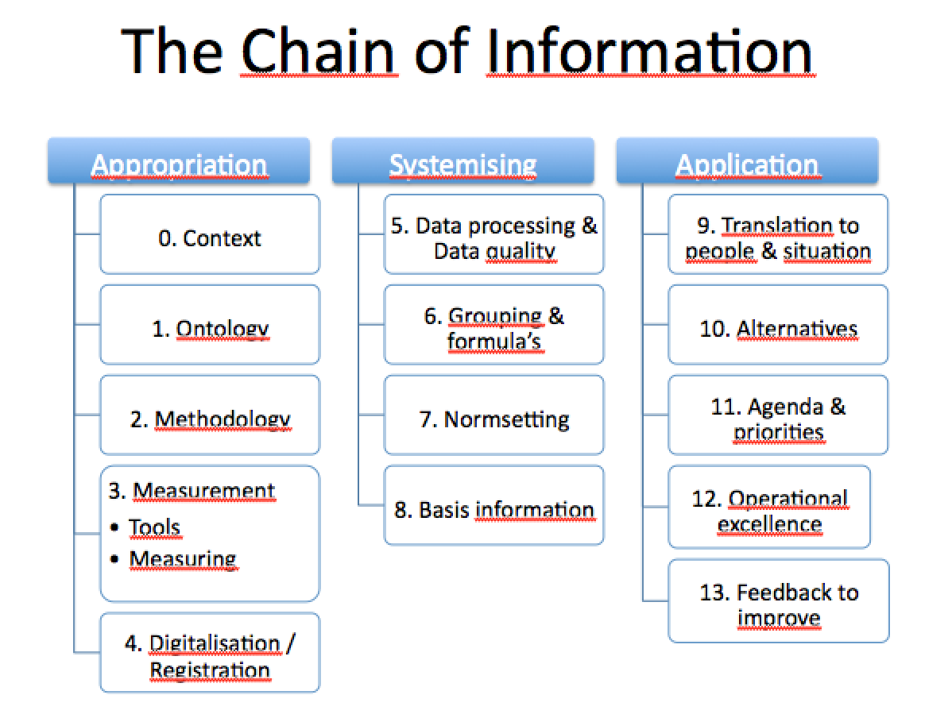

The first two phases are focused on generation of information. Here potential value is created. In the last, third phase, the value is realised, depending on the components 9-12. Component 13 is there to make the flow circular and enable improvement and progress. The Chain of Information concept is a general model for how information is created and used, and can act as a tool when the model is translated into a specific information flow.

* Appropriation is required to pull reality into the conceptual world. To think about reality, this must be translated into “think-things”, things we can think about, that fit within our brains and are suitable to theorise. This phase determines what we see from reality, both objectively (what is in scope) and subjectively (how is it translated).
* Systemising means using the force of ICT (“computer systems”). That force is in the speed of information processing; the memory capacity of the computer; and the mutual linkage between ICT systems (the communicating character). In this phase, data must be made available (often by cleaning for data quality) to enable clustering in groups, which are meaningful and appealing in the real world outside. Also, the processed information must be assessed according to norms set in order to become basis information.
* Information only has value when applied and makes a difference. Here, the conceptual flow must be brought back to reality, by translating the basic information to make it understandable for people addressed and fit to the situation at hand. Here, the information must be accurate, timely and complete to inform about a way of conduct, which fits within the relevant agenda’s, and priorities of involved managers. It also needs to be applied into the operations of the company, i.c. the conduct of employees, which requires operational excellence to work successful. The phases end with a feedback loop that brings the attention to previous links in the chain.

## Application of the Chain concept

As mentioned before, this concept was applied for the first time in a bank in a portfolio management department. For portfolio management, the first step is to get a good overview of the portfolio and its dynamics. That requires large amounts of information to be processed consistently to present a unified view on the portfolio. The next step is then to identify weak spots (positions in the portfolio that add the lowest value to the portfolio) and see how these spots can be improved. Finally, information is needed to monitor the effects of such portfolio management improvement actions.

After specifying the information needs, as shown above, the next step is to determine the processes in which such information is made and used, and identify the various steps taken in these processes, guided by the Chain of information concept.

With the Chain of Information concept, the various components of the chain have been analysed. This first involves a mapping of the abstract components in the model (e.g. 1. context) onto real life entities in the case, such as Head office, Regulator, client base, systems legacy, crisis legacy. The next step was to judge whether the respective portfolio management department was capable to change the component. For example, although the ontology and methodology used in the flow were considered inadequate, these could not be repaired by the portfolio management department, because they had to work with the metrics provided. They cannot change the regulations nor head office.

The result of that analysis was that the processing of information was the weakest component that could be improved. After doing so, it was possible to optimise the capitalisation of the portfolio, also because the result of actions could be monitored (information to monitor the actions could be processed). In turn, the successes of the actions can be communicated, building support for further actions.



capacity to process information

Obviously, when one weakest component is improved to above average in the chain, another component will turn out to be the next weakest. This may result in striving for continuous improvement.

--0—

To be elaborated

* ***Information management: FRAMING, SCREENING, SIGNALLING, MONITORING, IMPROVING, REFLEX***

## Literature and adjacent theories

To be elaborated ( and translated).

Risk Society according to Beck. In Beck’s story, risk is a sociological phenomenon that will affect the order of society. The strong progress in western science and the emancipation of various minorities in society since the 1960s coincide with the emergence of the risk society. And this development changes society fundamentally. For example, in reflexive modernity, the risk society, the axial principle is the distribution of bads, as opposed to the distribution of goods in industrial society.  
  
Typical features of risk society include:

1. Risks today induce systematic and often irreversible harm, generally remain invisible (because of the time aspect; risks by definition refer to future events), are based on causal interpretations, and thus initially only exist in terms of the (scientific or anti-scientific) knowledge about them. They can thus be changed, magnified, dramatised or minimised within knowledge, and to that extent are particularly **open to social definition and construction**. Beck refers explicitly to ecological risks and means by risks above all radioactivity, but also toxins and pollutants in the air, water and foodstuffs and accompanying effects on plants, animals and people. However, all risks relate to future and invisible events and rely on knowledge of causal relationships. This remark, in my opinion also is valid for other than ecological risks.
2. Some people are more affected than others by the distribution and growth of risks, that is **social risk positions spring up**. Risks of modernisation sooner or later also strike those who produce or profit from them. In that sense they contain a boomerang effect, which breaks up the pattern of class or national society. Connected to the recognition of modernisation, risks are ecological devaluations and expropriations, which frequently and systematically enter into contradiction to the profit and property interests which advance the process of industrialisation.
3. Civilisation or modernisation risks are big business, a bottomless barrel of demands, unsatisfiable, infinite and self-producible. With the **economic exploitation of the risks** it sets free, industrial society produces the hazards and the political potential of the risk society. Seeing risks as business then, the economy becomes self-referential, it produces the risks, which produce the economic area of risk management.
4. One can possess wealth, but one can only be afflicted by risks; they are ascribed by civilisation. Bluntly one might say: in class positions, being determines consciousness, while **in risk positions consciousness determines being**. The more chains of causes and effects we know of, the more risks we see. Knowledge gains a new political significance. Knowledge is one of the two basic resources to produce risk.
5. Risk society is a **catastrophic society**, it is focused on catastrophes. In it, the exceptional condition threatens to become the norm. And defence of the average threatens to become the goal.[[10]](#footnote-9)

Regarding the concept of risk, Beck shows us that risk not only comprises of cognitive, rational or scientific statements, but also comprises of normative statements. Science (or knowledge) is required to describe the chains of causes and effects that inflict the risks, but normative and judgemental statements are required to identify the risks, assess risks and evaluate risks. Statements on hazards are never reducible to mere statements of facts. As part of their constitution, they contain both a theoretical and a normative component. Risk statements combine knowledge about chains of causes and effects with normative judgements.  
  
In socially recognised risks, the authorities and agents of the modernisation process along with all their particular interests and dependencies are presumed, and are placed in a direct connection, in the pattern of cause and effect, with signs of damage and threats that are socially, substantively, spatially and temporally quite detached. Such risks can never be pure objectively determined.

Behavioural Finance by Tversky & Kahneman. Elaborate.

## Stiglitz[[11]](#footnote-10)Asymmetric Information Theory

* Assumption of asymmetric information; agents on one side of the market have much better information than those on the other side. Borrowers know more than lenders about their repayment prospects. This can give rise to ***adverse selection*** on markets, due to imperfect information. Borrowers with weak repayment prospects crowd out everyone else from the market[[12]](#footnote-11). Hypothetically, this information problem can either cause an entire market to collapse or contract it into an adverse selection of low-quality products. Therefore, economic agents may have strong incentives to offset the adverse effects of information problems on market efficiency. A proper credit assessment, resulting in a consistent and objective rating, used for calculation of EC can be a helpful tool to avoid this adverse selection.
* Better informed agents on a market can credibly transmit, “signal”, their information to the less informed, so as to avoid some of the problems associated with adverse selection. ***Signalling*** requires economic agents to take observable and costly measures to convince other agents of their ability or, more generally, of the value or quality of their products. A fundamental insight is that signalling cannot succeed unless the signalling cost differs sufficiently among the senders of information. An example concerns dividend payment by firms. Firms with “insider information” about high profitability pay dividends because the market interprets this as good news and therefore pays a higher price for the share. Another example concerns the costs of obtaining a credit rating and the expected lower credit risk premium paid on bonds issued because investors have better information. In latter case, the decrease of required risk premium must outweigh the costs of obtaining a rating. Note that it might even be impossible to issue bonds if no rating is available.
* Uninformed agents can take actions on a market with asymmetric information by creating incentives for the more informed agents to reveal information on their risk situation through so-called ***screening***. E.g. in an equilibrium with screening, insurance companies distinguish between different risk classes among their policy holders by offering them to choose from a menu of alternative contracts where lower premiums can be exchanged for higher deductibles. On credit markets with asymmetric information it can be shown that, in order to reduce losses from bad loans, it may be optimal for bankers to ration the volume of loans instead of raising the lending rate. Also analysed was the efficiency of financial markets in what is known as the Grossman-Stiglitz paradox: if a market were informationally efficient, i.e. all relevant information is reflected in market prices, then no single agent would have sufficient incentive to acquire the information on which prices are based.

## Cybernetics

Cybernetica is een redelijk jonge tak van kennis. Wiener[[13]](#footnote-12) introduceerde in 1947 cybernetica als volgt: We have decided to call the entire field of control and communication theory, whether in the machine or in the animal, by the name Cybernetics, which we form from the Greek χυβερνητησ, or steersman.”

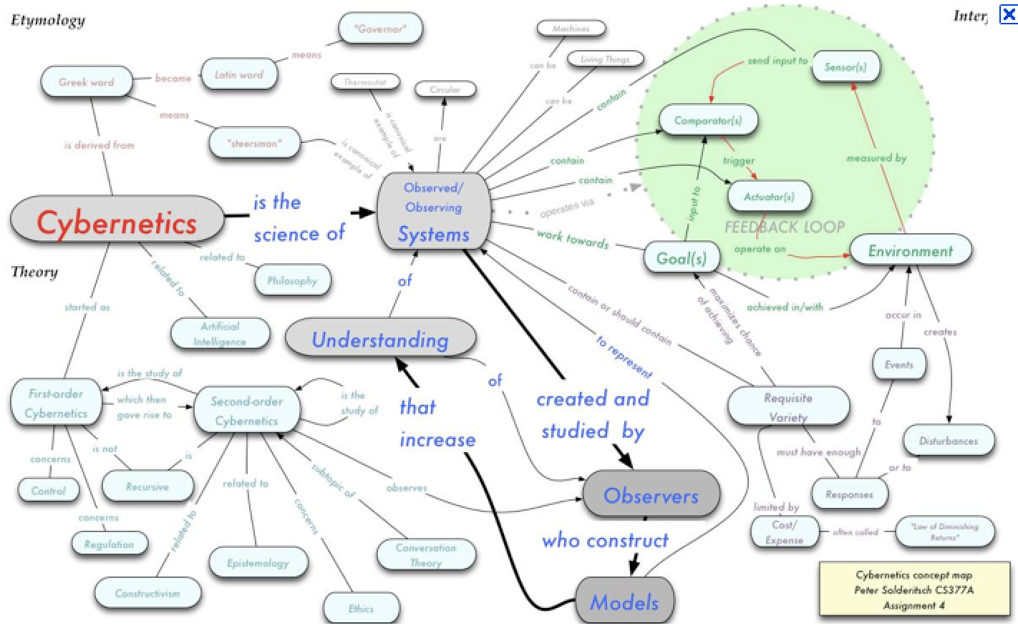

Cybernetica is stuurmanskunde, gaat over de controle en communicatie die nodig zijn om systemen te besturen. Een van de eerste problemen betrof het richten van Engels afweergeschut op de vliegtuigen van de (in de lucht) overmachtige Duitsers in 1944. De snelheid van de vliegtuigen was zo groot dat het geschut vóór het vliegtuig moest richten, en dus moest voorspellen waar het vliegtuig zich in de toekomst (na het afvuren van het geschut) zou bevinden. Dan speelt de snelheid van het vliegtuig een rol, net als die van de raket en de wind, maar ook de reactie van de piloot, de mogelijke uitwijkingsmanoeuvres gezien de bouw van het vliegtuig, de snelheid en de positie van het vliegtuig. Daarbij zal de piloot reageren op de raket, en de geavanceerde raket zal het vliegtuig opzoeken. Beiden zullen hun opponent aftasten en daarop hun actie aanpassen. Wederzijdse feedback binnen een context van vele variabelen. Cybernetica maakt dat allemaal berekenbaar en dus programmeerbaar, zodat verwerking door een computer mogelijk wordt.

Cybernetische systemen zijn niet exotisch, maar bevinden zich al jaren onder ons, in bijvoorbeeld de roersystemen van grote schepen, maar ook de thermostaat in huis is cybernetisch in het meten van de werkelijke temperatuur, de vergelijking daarmee met de gewenste en ingestelde temperatuur, en de aanpassing van de werking van de verwarmingsketel, waarbij ieder moment de temperatuur wordt gemeten om verder bij te stellen. Probleem binnen de cybernetica is dat duidelijk moet zijn wat de tijd is tussen het aanpassen van het systeem en de feedback. Dat merken we in een trage koude douche, waarbij we de warme kraan warmer draaien zolang het stromende water te koud voelt. Wanneer de verwarmingsketel ver weg is geplaatst en het dus lang duurt voordat het warme water ter plaatse is, zullen we veel te lang heter water willen. Wanneer het inmiddels zeer hete water eindelijk de douche bereikt, is de douche veel te heet en verbranden we. Wiener stelt dan ook terecht dat het programmeren van cybernetische systemen behoorlijk wat ervaring vereist in het betreffende gebied (in het voorbeeld loodgieterervaring over hoe lang het duurt tot het hete water bij de douche is).

De systeemtheorie is de meest bekende huidige toepassing van cybernetica in de organisatiekunde. De systeemtheorie biedt een holistische benadering die gericht is op de wisselwerking tussen elementen binnen het systeem en met andere systemen. Daarbij wordt niet alleen reductionistisch gekeken naar de afzonderlijke elementen van een systeem, maar wordt tevens het systeem als geheel geanalyseerd, omdat het geheel meer is dan de som der delen. Dat maakt systeemtheorie een buitenbeentje binnen de moderne wetenschap, die reductionistisch en statisch is, met een universele waarheid die altijd en overal geldt (en waarmee een goede blauwdruk is te maken).

Cybernetica komt uit de *engineering* en biedt de mogelijkheid om dynamica te incorporeren in de communicatie en controle systemen, vanuit de ervaring dat dat essentieel is om een goed werkende *apparatus* te bouwen. Engineering staat met meer benen op de aarde omdat zij de taak heeft goed werkende systemen op te leveren, anders dan de meer theoretische wetenschap, of de niet verifieerbare sociale statistiek.

Cybernetica laat ook duidelijk zien dat vaak meerdere feedbacksystemen nodig zijn voor besturing van complexe additieve systemen.   
Er zijn patienten die weliswaar voldoende kracht hebben in hun spieren, maar die kracht niet kunnen doseren. Wanneer zij een glas water naar hun mond brengen doen ze dat met veel te grote en te snelle beweging, zodat het glas voorbij hun schiet. Wanneer ze het glas dan weer willen terugbrengen naar hun mond schieten e hun mond de andere kant op voorbij. Voordat ze hebben kunnen drinken is het glas reeds leeg.

Dit voorbeeld laat zien dat niet alleen de positie van de hand met het glas ten opzichte van de mond moet worden gemeten, maar dat er een tweede meting nodig is, namelijk die de snelheid van de beweging controleert waarmee het glas naar de mond wordt gebracht. Heisenberg wees in het begin van de 20e eeuw hierop in wat het Heisenberg Principe is gaan heten: in quantumdynamica is het onmogelijk om exact de positie en snelheid van een object tegelijkertijd te meten. Voor het accuraat meten van de positie is een hoogfrequent licht nodig, terwijl die hoge frequentie de snelheid van het gemeten object zal veranderen door de energie van de hoge frequentie. Om de snelheid dus te meten zal een laagfrequent licht moeten worden gebruikt, waardoor echter de positie niet accuraat kan worden vastgesteld.

De realiteit leert dat dynamica een gegeven is en dat het verleden zich niet precies herhaalt. De huidige financieel gerichte control systemen gaan uit van een statische werkelijkheid, technisch gezien een Newtoniaanse fysica, waarbij op ieder moment in principe alle informatie aanwezig is om zowel verleden als toekomst perfect te voorspellen. Dat soort denken maakt een blauwdruk mogelijk, waarin gedurende het jaar geen ruimte is om op onverwachte ontwikkelingen te reageren, want die zijn niet opgenomen in het budget. Sterker nog, in een Newtoniaanse ruimte komen geen onverwachte ontwikkelingen voor. In een dynamische en complexe sociale werkelijkheid geldt die Newtoniaanse fysica niet meer en ervaren we dat de blauwdruk vooral bij grote projecten keer op keer vals blijkt. Cybernetica biedt dan de instrumenten die het gemis aan controle door het opgeven van de blauwdruk meer dan kunnen compenseren.

## Polanyi’s Tacit Knowledge

When I first came to credit risk management departments I was impressed by the in-depth knowledge of senior credit officers who had been in the field for more than twenty years. By their long experience, they had a feeling for what goes on at the customer and seem to be able to read between the figures. Although their evaluation and judgement was not always clearly argumented, even with hindsight their assessments proved right in many cases. Judgements were allowed to be based on some kind of intuitive feeling of senior officials; although they could not explain, they were able to distinguish good loans from bad ones in many cases. The right thing had their attention, and how they are able to be that informed is of no concern. Credit risk management seems to be concerned not with an adequate argumentation, but with the right decision. You don’t have to assess the million factors which can cause a default on one’s obligations, you only need to look at the right signals and be alert. Exactly how this is achieved remains a mystery to me, or better stated: it looks like a skill. In my opinion, the structure of credit risk management, considered as a type of knowledge resembles a skill.

The credit committee (CC) members read through the balance sheet and Profit & Loss numbers, which are in many cases inflated by the window dressing of banks and make up their opinion, despite the complications in the data or the analysis presented to them. From a philosophy of travelling point of view, it is clear that the CC members are not interacting with the (potential) clients of the bank directly. Their interaction with them is mediated by the credit application presented to the committee. The credit application in many cases itself is not a product of direct interaction with the counterparty. For large parts, the credit application is written by a credit analyst who never saw the client. So the CC members in fact make a long virtual journey when they focus on a prospect credit risk, being mediated by a credit application, by a credit analyst, by a relationship manager, who in the end interacts with the client.

Still, we can conclude that they are doing their job quite well, given that all banks employ such people. From a philosophy of travelling point of view, it is interesting to learn how these CC members gain and maintain their knowledge about counterparties.

Michael Polanyi (in 1966) was one of the first in modern philosophy who pointed explicitly at this type of knowledge when he launched the term Tacit Knowledge. Someone knows so much more than he can tell, and if he could tell, the words he is using have so much more meaning and rely on too much language-contexts to explain. A pianist can play virtuously without being able to explain exactly how his fingers move over the keyboard.

According to Polanyi[[14]](#footnote-13) Tacit Knowledge has the structure of a skill, “…for a skill combines elementary muscular acts which are not identifiable, according to relations that we cannot define.”

The basic structure of tacit knowing always involves two things, or two kinds of things. The first term are specific, tacit, particulars of which we become aware only by what they signify and looks as their effect. We may say that we learn to rely on our awareness of these particulars for the purpose of attending to their significance, the second term, on which our attention is focused. This is the basic definition of the logical relation between the first and second term of a tacit knowledge. It combines two kinds of knowing. We know the effect, forming the second term, by attending to it, and hence the subject is *specifiably* known. But we know the effect-producing particulars only by relying on our own awareness of them for attending to something else, namely the effect, and hence our knowledge of them remains *tacit*. This is how we come to know these particulars, without being able to define them. Such is the *functional relation* between the two terms of tacit knowing: *we know the first term only be relying on our awareness of it for attending to the second.*

In many ways the first term of this relation will prove to be nearer to us, the second further away from us. Using the language of anatomy, we may call the first term *proximal*, and the second term *distal*. It is the proximal term, then, of which we have a knowledge that we may not be able to tell.

In the exercise of a skill, we are aware of the several muscular moves in terms of the performance to which our attention is directed. We may say, in general, that we are aware of the proximal term of an act of tacit knowing in the appearance of its distal term; we are aware of that *from* which we are attending *to* another thing, in the *appearance* of that thing. We may call this the *phenomenal* structure of tacit knowing.

But there is significance in the relation of the two terms of tacit knowing which combines functional and phenomenal aspects. When the sight of certain particulars makes us expect a specific effect, we may say that they *signify* the approach of the effect. This is their *meaning* to us. We may call this the *semantic* aspect of tacit knowing. All meaning tends to be displaced *away from ourselves*, and that is in fact the justification for using the terms “proximal” and “distal” to describe the first and the second term of tacit knowing.

From the three aspects of tacit knowing that have been defined so far –the functional, the phenomenal, and the semantic- we can deduce a fourth aspect, which tells us what tacit knowing is a knowledge of. This will represent its *ontological* aspect. Since tacit knowing establishes a meaningful relation between two terms, we may identify it with the *understanding* of the comprehensive entity which these two terms jointly constitute. Thus the proximal terms represent the *particulars* of this entity, and we can say, accordingly, that we comprehend the entity by relying on our awareness of its particulars for attending to their joint meaning.

With reference to the above, we may call the credit risk portfolio modelling projects within banks joining the EC movement a search for the particulars of credit risk. Given that the EC framework requires a considerable amount of econometrics and its fuel: data, it is comprehensible that most of the modelling work is being done by departments who know more about econometrics than about credit risk These modellers rely on data for their activity. That concerns data, which in many banks was never systematically recorded because credit risk was not oriented on econometrics previously. In terms of Polanyi one could question how can we quantify the proximal in order to assess the distal? Especially when we have no experience or interaction with the distal (being the actual behaviour of a counterparty during the tenor of the contractual obligations of him).

One of the most striking concrete examples of an experience that cannot possibly be represented by any exact theory is an experience within science itself: the experience of seeing a problem, as a scientist sees it in his pursuit of discovery. Plato shows the contradiction in problems in the *Meno* when he says that, to search for the solution of a problem is an absurdity; for either you know what you are looking for, and then there is no problem; or you do not know what you are looking for, and then you cannot expect to find anything…

We must conclude that the paradigmatic case of scientific knowledge, in which all the faculties that are necessary for finding and holding scientific knowledge are fully developed, is the knowledge of an approaching discovery.

To hold such knowledge is an act deeply committed to the conviction that there is something to be discovered. It is personal, in the sense of involving the personality of him who holds it, and also in the sense of being, as a rule, solitary; but there is no trace in it of self-indulgence. The discoverer is filled with a compelling responsibility for the pursuit of a hidden truth, which demands his services for revealing it. His act of knowing exercises a personal judgement in relating evidence to an external reality, an aspect of which he is seeking to apprehend. Polanyi deviates here from the modernist view which states that all knowledge should be objective, discarded of personal beliefs and convictions.

Polanyi[[15]](#footnote-14) provides an ontological status to tacit knowledge by way of what he calls indwelling or interiorisation of the senses of the body into real entities: “Whenever we use certain things for attending *from* them to other things, in the way in which we always use our own body, these things can change their appearance. They appear to us now in terms of the entities to which we are attending *from* them, just as we feel our own body in terms of the things outside to which we are attending *from* our body. In this sense we can say that when we make a thing function as the proximal term of tacit knowing, we incorporate it in our body – or extend our body to include it – so that we come to dwell in it…It brings home to us that it is not by looking at things, but by dwelling in them, that we understand their joint meaning.”

Note that this means that tacit knowledge requires bodily contact; requires the body as epistemological tool. In this respect, Polanyi takes a similar view as Nietzsche, see § 7.3.1.

Polanyi[[16]](#footnote-15) proves to be a modernist realist when stating that: “It seems plausible then to *assume in all other instances of tacit knowing the correspondence between the structure of comprehension and the structure of the comprehensive entity which is its object.* And we would expect then to find the structure of tacit knowing duplicated in the principles which account for the stability and effectiveness of all real comprehensive entities.”

Polanyi shows his modernist character here in specifying the ontology of correspondence between comprehension and matter. This in fact is quite a strong statement, requiring correspondence between knowing and that which is known. After postmodernism, correspondence is a big problem. The philosophy of travelling equivalent of this only speaks of appropriation – not correspondence- leaving autonomy to the object.

However, different than conventional correspondence-thinkers, Polanyi does not assume that the object can ever be completely captured; can ever be fully specified by our knowledge. There is no full correspondence, as he leaves space for the unexpected[[17]](#footnote-16): “This capacity of a thing to reveal itself in unexpected ways in the future I attribute to the fact that the thing observed is an aspect of reality, possessing a significance that is not exhausted by our conception of any single aspect of it. To trust that a thing that we know is real is, in this sense, to feel that it has the independence and power for manifesting itself in yet unthought-of ways in the future.”

The value of this conclusion about reality is in line with the distinction between the known and unknown. Knowing that you don’t know everything. This helps us to expect the unexpected systematically. That in turn helps us to anticipate surprises. Eg. we can prepare ourselves for situations which are different than currently, and especially those different situations which we experience as negative. Exactly that is the essence of risk management; to anticipate surprises and set up arrangements to mitigate the effect of future hazards.

Nozick points at the features of objectiveness (autonomy, power to surprise) when he refers to the same reality, and need for the existence of an independent reality. It is this objective real world which is the focus of scientific inquiry, a reality to which third parties or third significances also have access, because it is independent from me – the subject, participant and observer. Its independence allows it to surprise us a few times.

All three positions (philosophy of travelling, Polanyi and Nozick) acknowledge the essential status of the real world for knowledge building. They are all realistic episteme, instead of idealistic.

A final remark regarding Polanyi[[18]](#footnote-17) concerns the issues of emergence & marginal control.

”Take two points. (1) Tacit knowing of a coherent entity relies on our awareness of the particulars of the entity for attending to it; and (2) if we switch our attention to the particulars, this function of the particulars is cancelled and we lose sight of the entity to which we had attended.[[19]](#footnote-18) The ontological counterpart of this would be (1) that the principles controlling a comprehensive entity would be found to rely for their operations on laws governing the particulars of the entity in themselves; and (2) that at the same time the laws governing the particulars in themselves would never account for the organising principles of a higher entity which they form…Thus each level is subject to dual control; first by the laws that apply to its elements in themselves and, second, by the laws that control the comprehensive entity formed by them…We may call the control exercised by the organisational principle of a higher level on the particulars forming its lower level *the principle of marginal control*…

If each higher level is to control the boundary conditions left open by the operations of the next lower level, this implies that these boundary conditions are in fact left open by the operations going on at the lower level. In other words, no level can gain control over its own boundary conditions and hence cannot bring into existence a higher level, the operations of which would consist in controlling these boundary conditions. Thus the logical structure of the hierarchy implies that a higher level can come into existence only through a process not manifest in the lower level, a process which thus qualifies as an emergence.”

Polanyi indirectly urges us to investigate further into our credit risk than just using “the data”. This data, even if perfect, can never tell us exactly how the counterparty is doing. Indwelling, bodily contact is required to appropriate a skill.

The principle of marginal control tells us that the health of a counterparty as a whole can not be found in particular data regarding aspects of the counterparty. Econometrists that purely rely on data miss the point they are looking for.

## Literature list

1. United States Army command and general staff college, Adaptation, Learning, and the art of war: a cybernetic perspective, Amazon Distribution GmbH, Leipzig, 2014?
2. in R.A. Meyers (ed), Encyclopedia of Physical Science & Technology, (3rd ed), Academic Press, New York, 2001: Cybernetics and second order cybernetics, Francis Heylighen, Free University of Brussels…
3. Stafford Beer, The Viable System Model, [www.managementkybernetik.com](http://www.managementkybernetik.com), 1989
4. George A. Akerlof, A. Michael Spence, Joseph E. Stiglitz, Markets with asymmetric Information, https://www.nobelprize.org/nobel\_prizes/economic-sciences/laureates/2001/advanced-economicsciences2001.pdf , 2001
5. Evgueni Ivantsov, Heads or Tails, Financial disaster, Risk Management and Survival Strategy in the world of extreme risk, Routledge, London, 2016.
6. Nozick, R., Invariances, the structure of the objective world, Harvard University Press, 2001, Cambridge, Massachusetts.
7. P. Checkland in Checkland, P., Systems Thinking, Systems Practice, John Wiley and Sons Ltd., West Sussex, 1993.
8. Beck, U. Risk society: Towards a new modernity. Sage, London, 1992

1. Beck, U. Risk society: Towards a new modernity. Sage, London, 1992 [↑](#footnote-ref-0)
2. <https://www.forbes.com/sites/bernardmarr/2015/09/30/big-data-20-mind-boggling-facts-everyone-must-read/#3eb9389917b1>, 23-03-2018. [↑](#footnote-ref-1)
3. An asset is something that can produce cash now or in the future. [↑](#footnote-ref-2)
4. Wikipedia, mar 18, https://en.wikipedia.org/wiki/Prospect\_theory: Prospect theory is a behavioral economic theory that describes the way people choose between probabilistic alternatives that involve risk, where the probabilities of outcomes are unknown. The theory states that people make decisions based on the potential value of losses and gains rather than the final outcome, and that people evaluate these losses and gains using certain heuristics. The model is descriptive: it tries to model real-life choices, rather than optimal decisions, as normative models do.

   The theory was created in 1979 and developed in 1992 by Daniel Kahneman and Amos Tversky as a psychologically more accurate description of decision making, compared to the expected utility theory. In the original formulation, the term prospect referred to a lottery. The paper "Prospect Theory: An Analysis of Decision under Risk" (1979) has been called a "seminal paper in behavioral economics".[1] [↑](#footnote-ref-3)
5. Term of P. Checkland in Checkland, P., Systems Thinking, Systems Practice, John Wiley and Sons Ltd., West Sussex, 1993. A system is soft when people play the dominant role. [↑](#footnote-ref-4)
6. <https://en.wikipedia.org/wiki/Electron_rest_mass> 23-03-2018: It is impossible to "weigh" a stationary electron, and so all practical measurements must be carried out on moving electrons.  [↑](#footnote-ref-5)
7. Stephen Hawking speaks of the highest speed allowed. [↑](#footnote-ref-6)
8. In order to refrain from Feyerabend’s “ Anything goes”, as answer to the conclusion that our knowledge is not objective. [↑](#footnote-ref-7)
9. Nozick, p.17 [↑](#footnote-ref-8)
10. Beck points at issues that can have significant impact on society in terms of risk distribution, political significance of knowledge and defense of the average. However interesting, these social implications will only be discussed in part two of this thesis, chapter nine.

    [↑](#footnote-ref-9)
11. George A. Akerlof, A. Michael Spence, Joseph E. Stiglitz, 2001 [↑](#footnote-ref-10)
12. Eg. weak borrowers will present themselves as better quality and hence, inflate the realised required risk premium for that rating bucket in the end (when higher default rates will have realised). [↑](#footnote-ref-11)
13. N. Wiener, Cybernetics, or the control and Communication in the animal and the machine, MIT press, Massachussetts, 1961 [↑](#footnote-ref-12)
14. Polanyi, Michael, The tacit dimension, copyright 1966, reprinted 1983, Doubleday & Company Inc., p. 8-9 [↑](#footnote-ref-13)
15. Polanyi, p.16-18 [↑](#footnote-ref-14)
16. Polanyi, p.33 [↑](#footnote-ref-15)
17. Polanyi, p.32 [↑](#footnote-ref-16)
18. Polanyi, p.34 [↑](#footnote-ref-17)
19. In Dutch we say: through all the trees we don’t see the forest anymore. We can’t see the woods from the trees? [↑](#footnote-ref-18)